Project Description:

I am building an application for weather forecast where On home page or first page you see the current temperature in celciuos and it has alos another page where you can see next seven days weather when click the 7 day forecast button it will take you to the next screen and will show you the real time weather update for next 7 days and it can retrieve the weather from any location as I use the Weather API. For my project, I have used view models, fragments, networking, and repositories. And data classes where all the city country and location are involve. I have use constraint and other necessary things to make me

Application looks perfect.

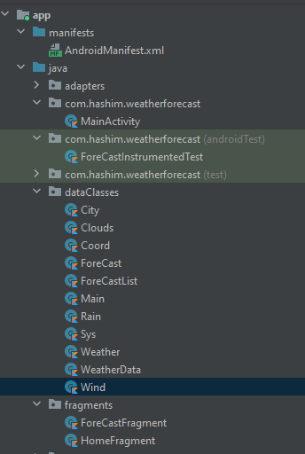

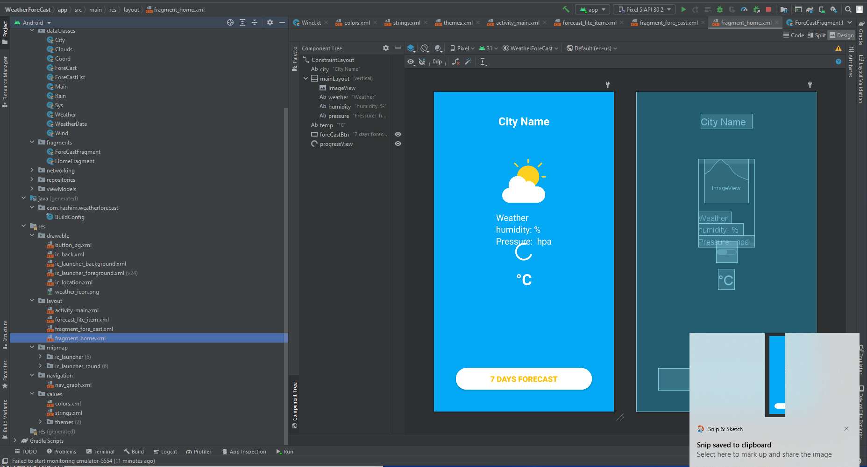

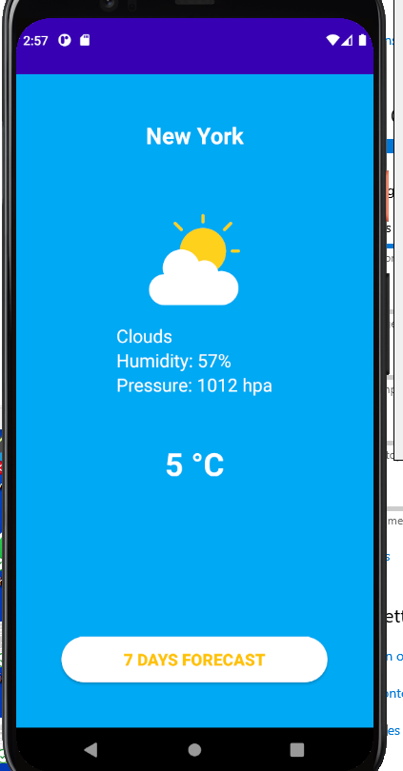

GITHUN LINK: https://github.com/Shashim27/A.H-Pollob-/upload/main